51.2.5.7 Browse eshop registrations
We check in this function all new incoming registration made by our new clients via our e-shop.

Below you can see my settings as I´m in charge in different countries.
Make your own settings by using Country Code = NL + Validated = NO.
Each new line without Remarks means a new registration (yellow highlighted below).
All new incoming registrations have REMARKS field as blank.
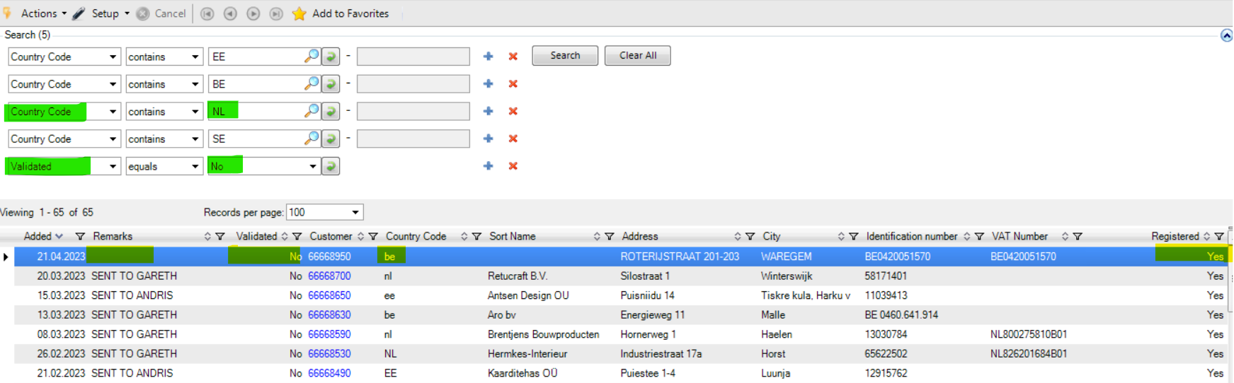
I´m checking this report on a daily base. You can make the function to be automatically opened always when opening QAD. Please, set as below. It works for all functions in your Favorite list, so you can set also for another as Hranipex Articles, 51.2.2.22, etc.
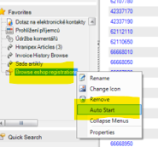

At the same time we recieve informaiton about such a new registration to your mailbox.
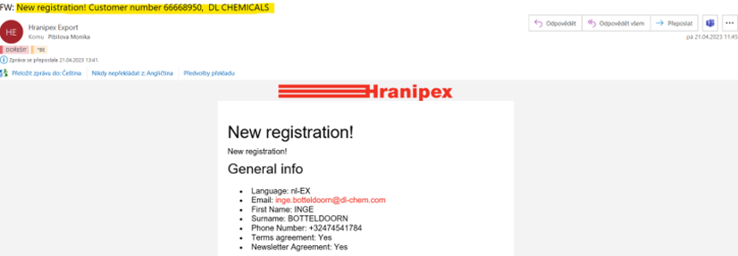
What to do with a new registration?

If salesman wants to set this new client as Validated.
Means that we want to cooperate with this new client directly and we need to set all necessary data in QAD as below.

2.1.1 Customer Maintenance
36.21.12.1 Change EAN of partner + 36.21.1 Parametrs of Partner – Maintenance
2.1.8.10 Customer Price Report
+ settings in QAD CRM

I´m resending the mail regarding a new registration to a salesman to check below and set in QAD:

2.1.1 PAYMENT CONDITIONS (for NL clients usually 30-0-0, but each salesman decides)
2.1.1 VAT number correct and valid / checking via https://ec.europa.eu/taxation_customs/vies/
2.1.1 VALIDATED: if clicked, means that above payments term will be displayed for this new particular client on e-shop and also means that we have maintained all data (including price lists) and confirmed this new client as valid.
2.1.8.10 PRICE LIST SETTINGS (for all categories or some category can be excluded)
QAD CRM we need to set e-shop login here and clicked the box for sending of invoices to correct persons (manual will come soon)

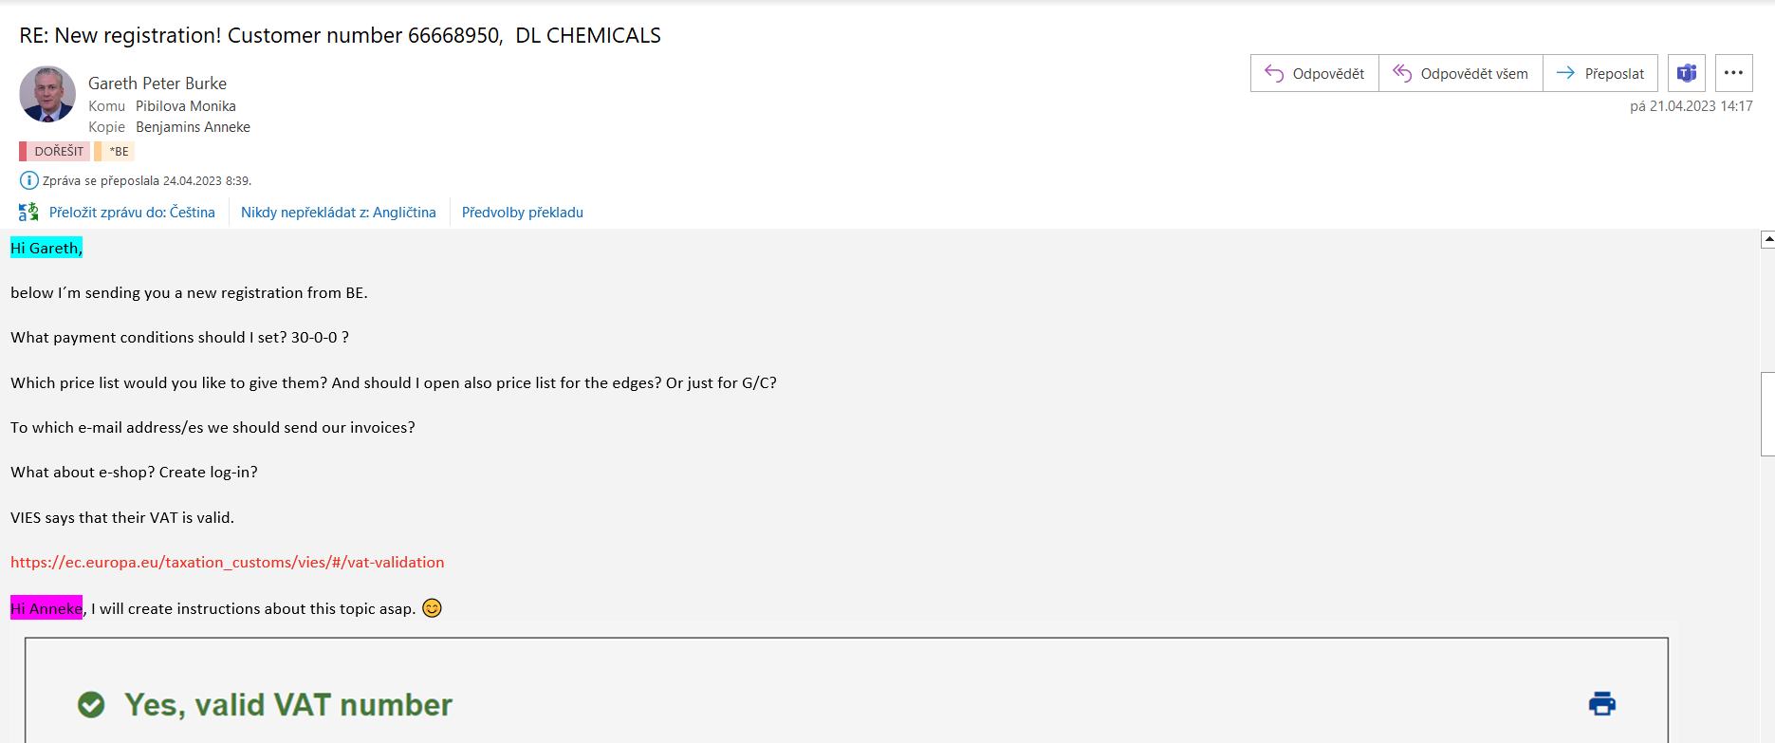

Sometimes it may be desirable to classify the customer under our distributor or there is another reason why to do not validate this new registration.
2.1.1 REMARKS: I write here always to which salesman I sent this new registration. If a salesman decides that we don´t want to make this customer as valid, then I can see in report 51.2.5.7 that we have already took care about this and there is no need to check it again.
All new incoming registration has REMARKS field as blank.
2.1.1 VALIDATED: remain uncklicked

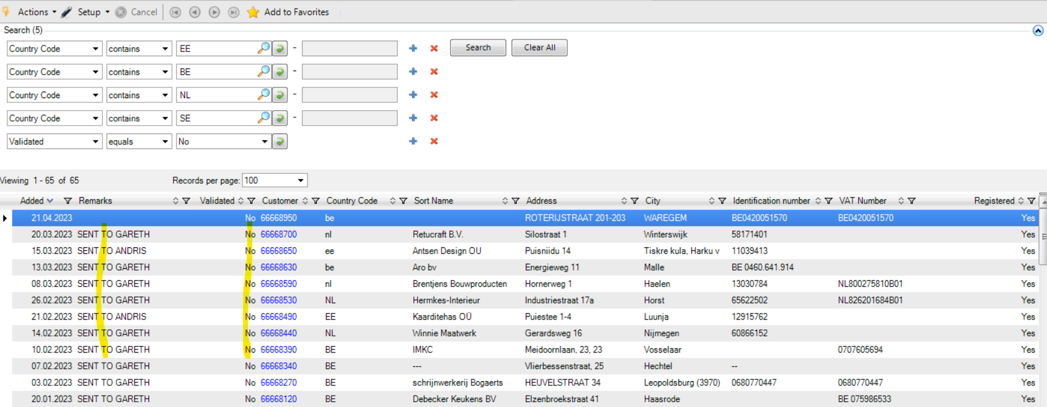

NOTE: Kindly note that UNVALID customer doesn´t mean that they cannot create their own login and order via e-shop. See below mail to Gareth from 27.4.2023, regarding this topic.

